# **Gitfolio Manual Test Plan**

## Test start app

Run the app on a random android device or an emulator. Make sure the first screen you see is as followed:

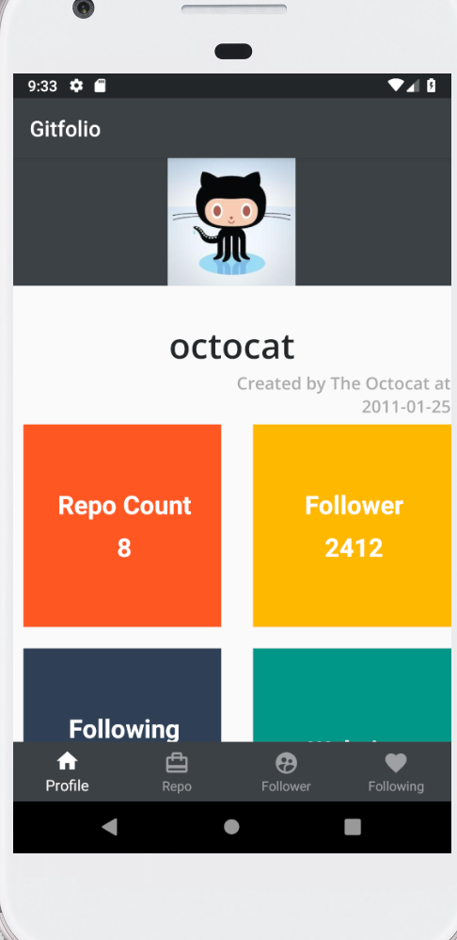

## Test Navigation

Click the 4 icons on the bottom navigation bar and make sure each button behaves normally as followed:

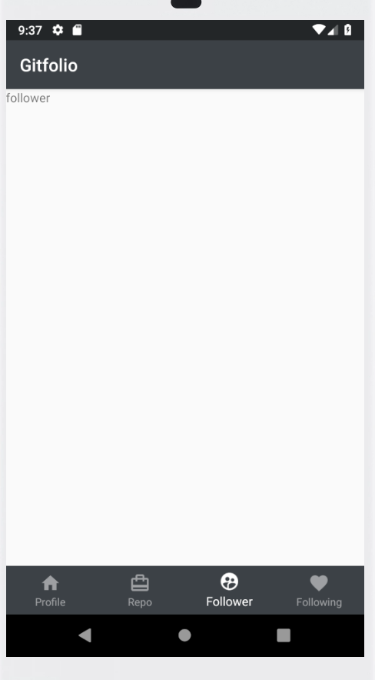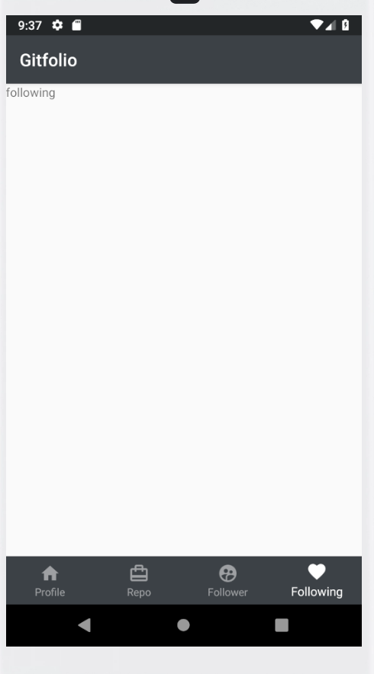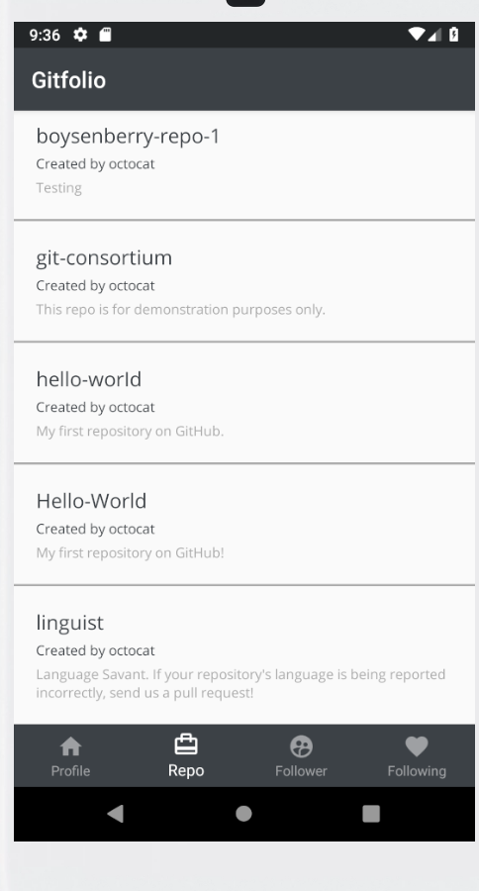

## Test Profile Page

Once again click the “Profile” button on the bottom navigation bar and the profile page will appear.

In your browser, visit <https://api.github.com/users/octocat>. A json record will appear. Make sure the numbers on the app and website match with each other.

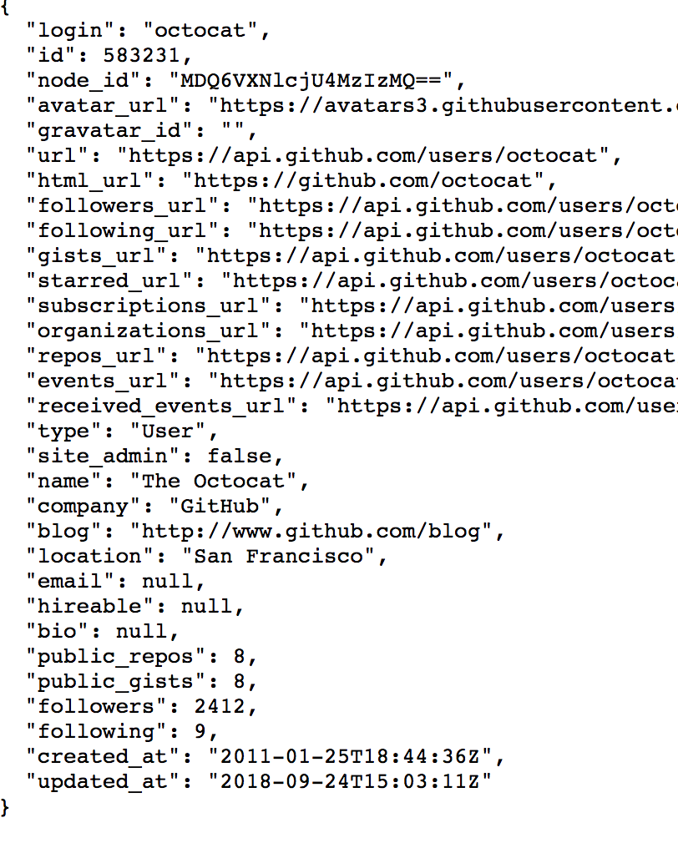

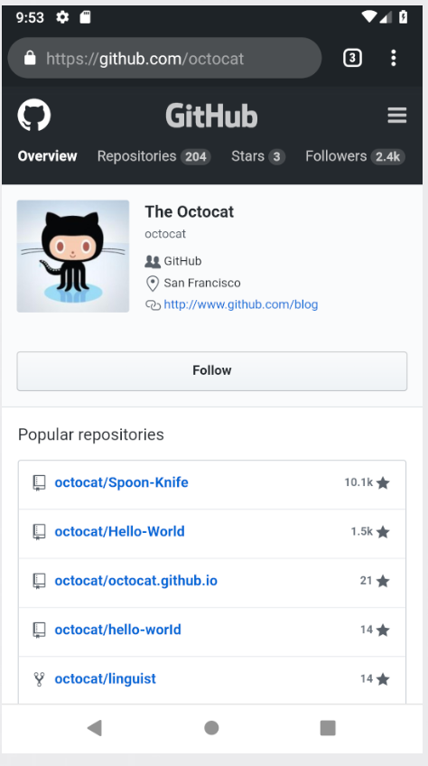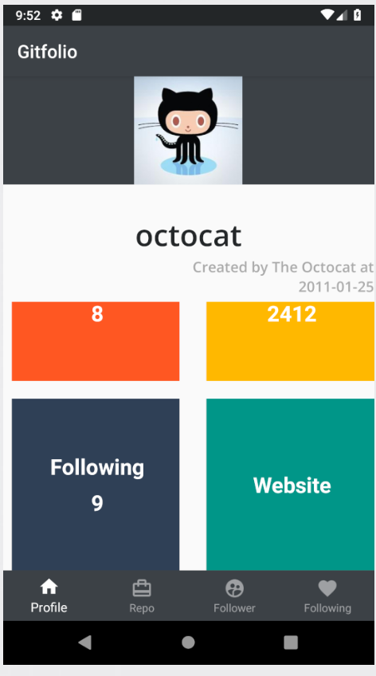Click the Website block. It will take you to the Github profile in the browser.

## Test Repo Page

Click the “Repo” button on the bottom navigation bar and the profile page will appear.

In your browser, visit https://api.github.com/users/octocat/repos. A json list will appear. Make sure the owner.login, name, and description on the app and website match with each other.

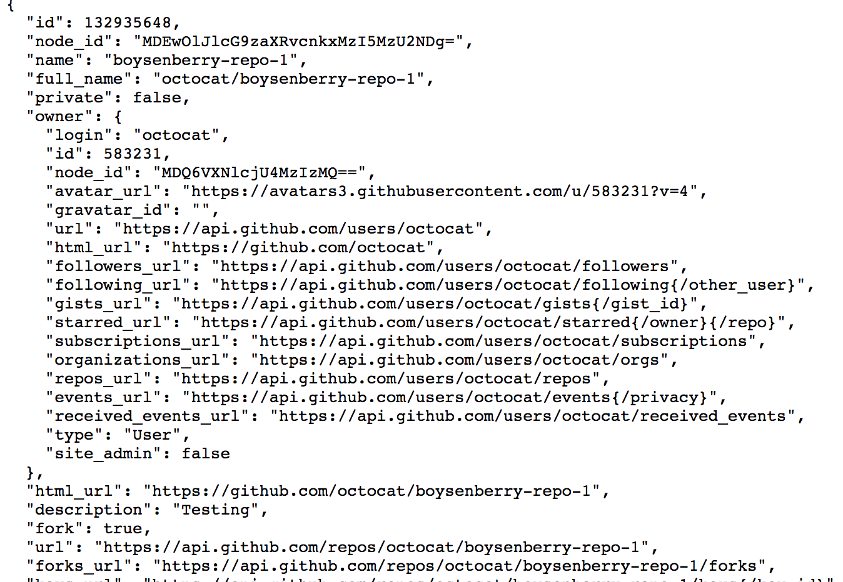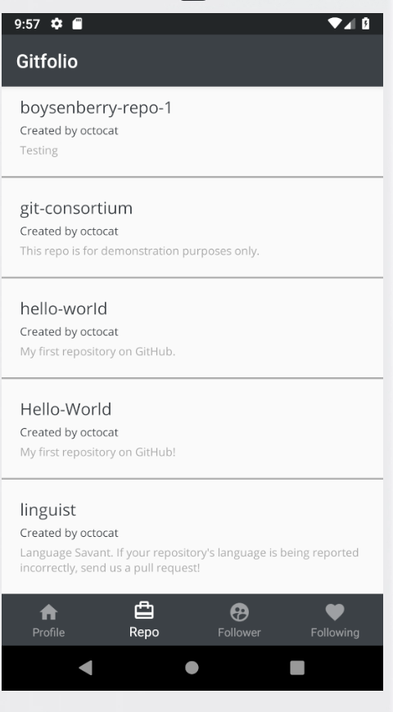

Click each name of the repo and you will be redirected to the repo page in your browser.

